1. Create one VPC,with 1 one public subnet and 1 private subnet.

First we have go to aws and select vpc

Next go to your vpac and create vpc

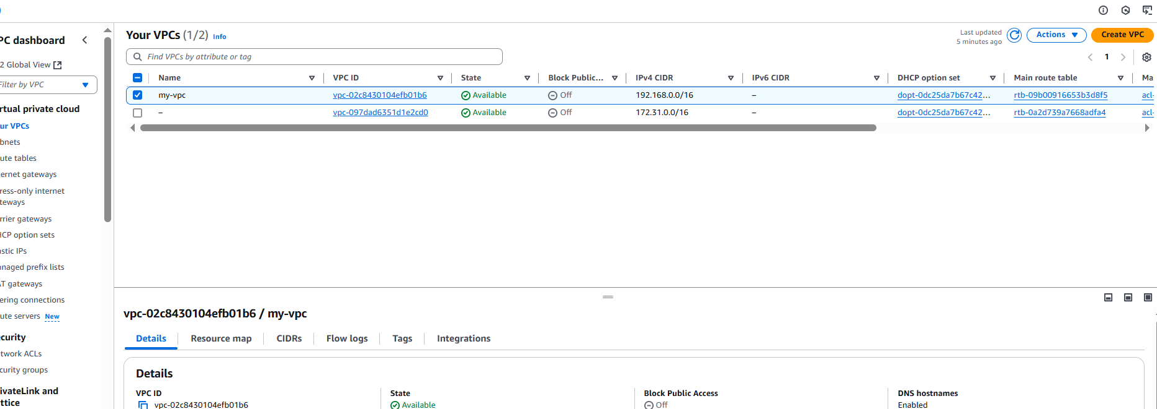

Next got subents in vpc

After create subnets for public and private

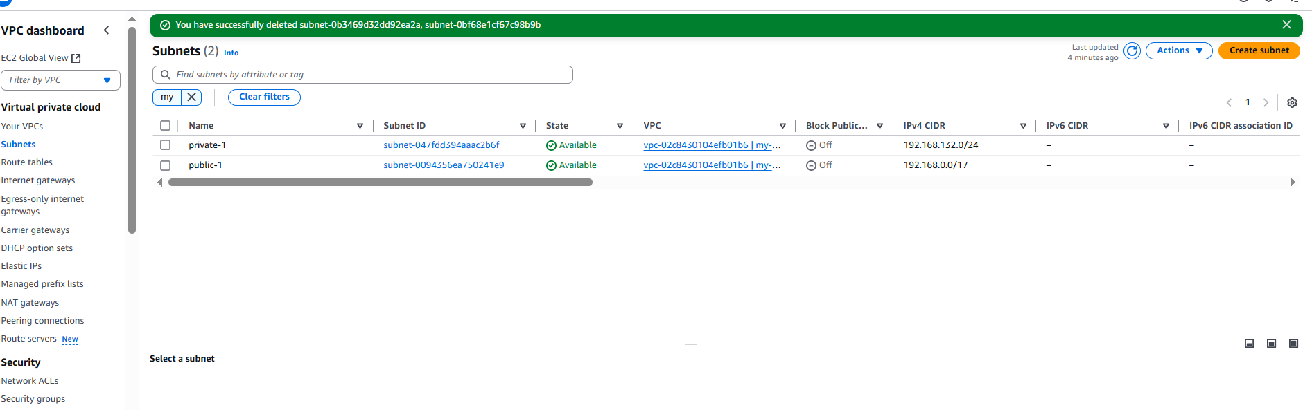

1. Enable VPC peering for cross region.

First go to aws and the vpc

In that go to your vpc create two new vpc’s

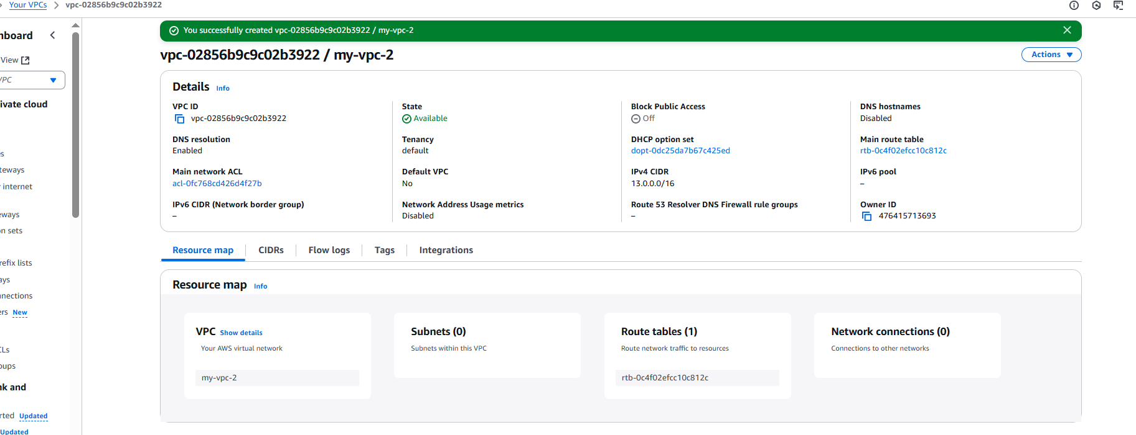

After that go to the route table

And create two new route tables

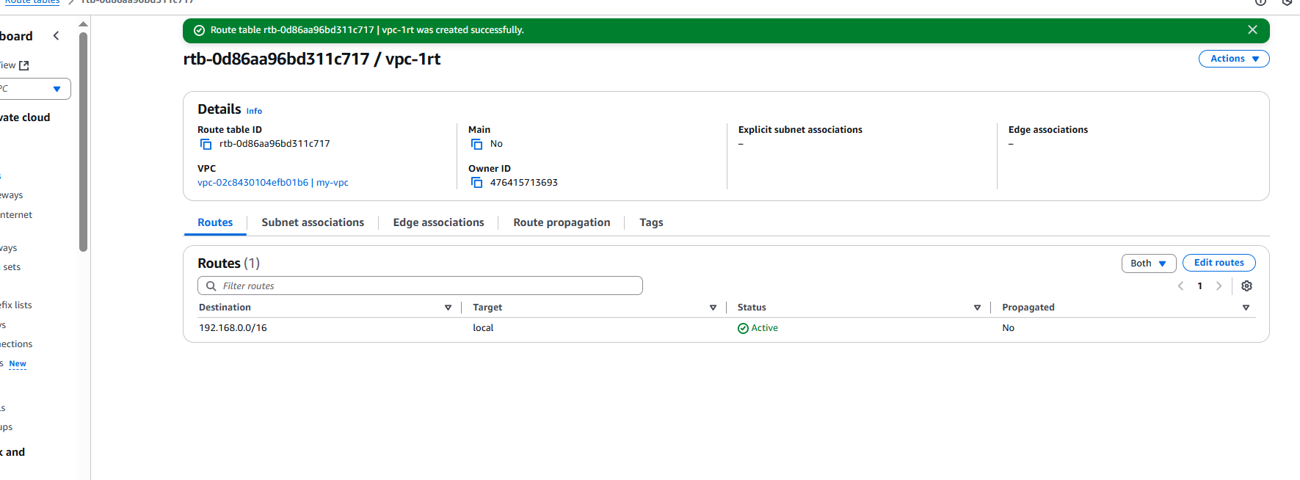

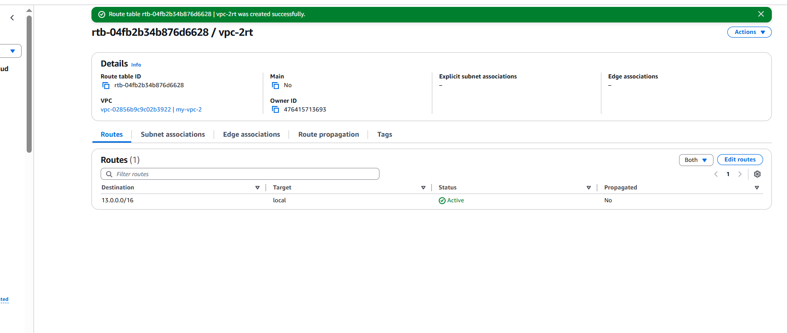

Go to subnets in vpc

And create two new subnets

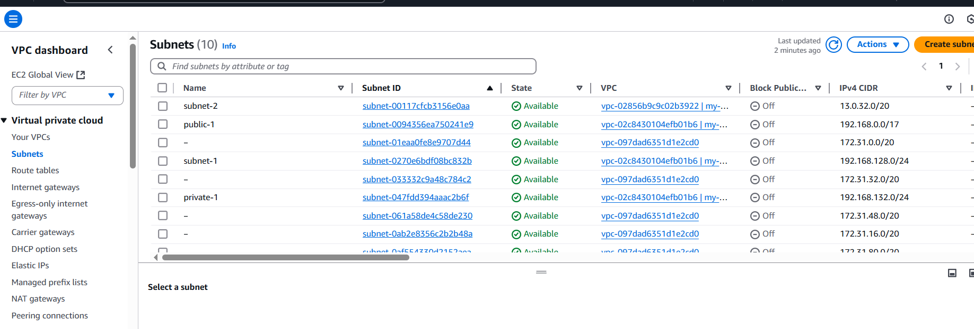

Next go to vpc peering connection and create a new one

Next add this in the route table for peering connecting

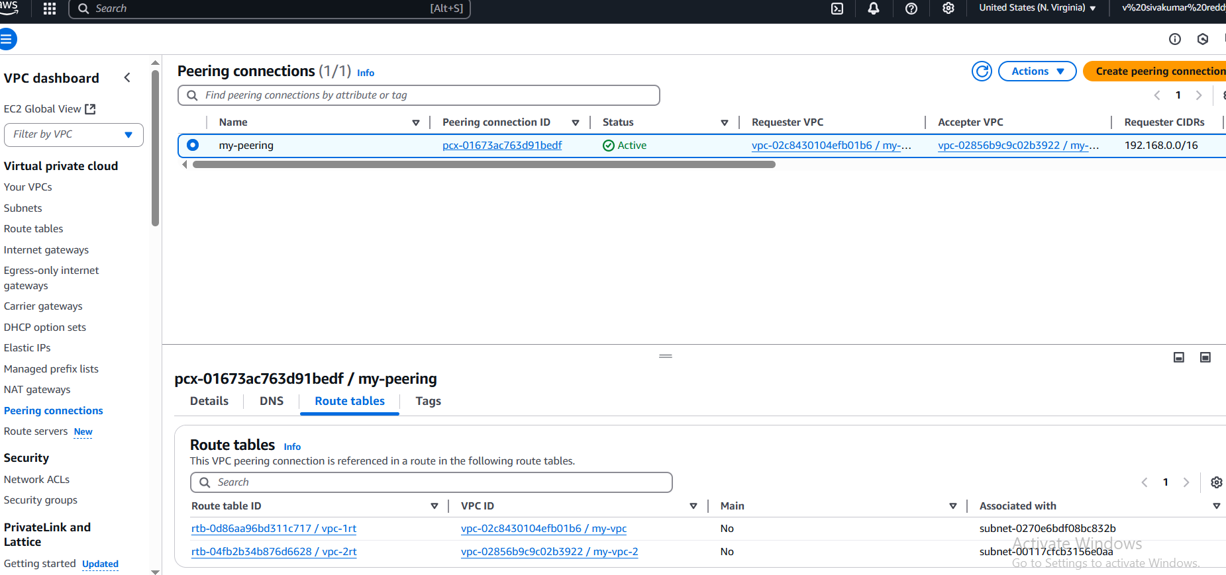

Launch two instances for vpc cross peering connection

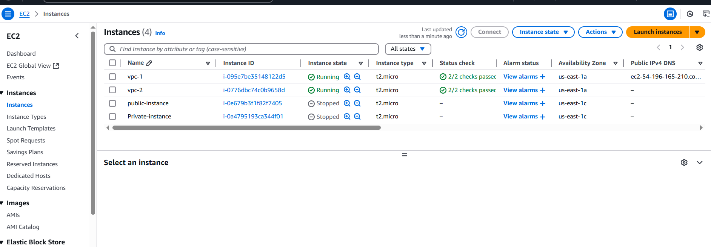

Login with ssh in terminal vpc-1 instnce

After that give the command curl @ with vpc-2 private ip

It will run what we have given the html script for http

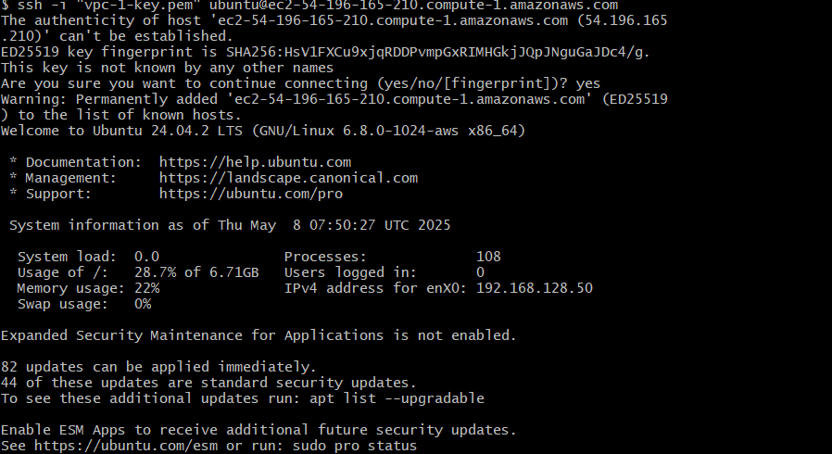

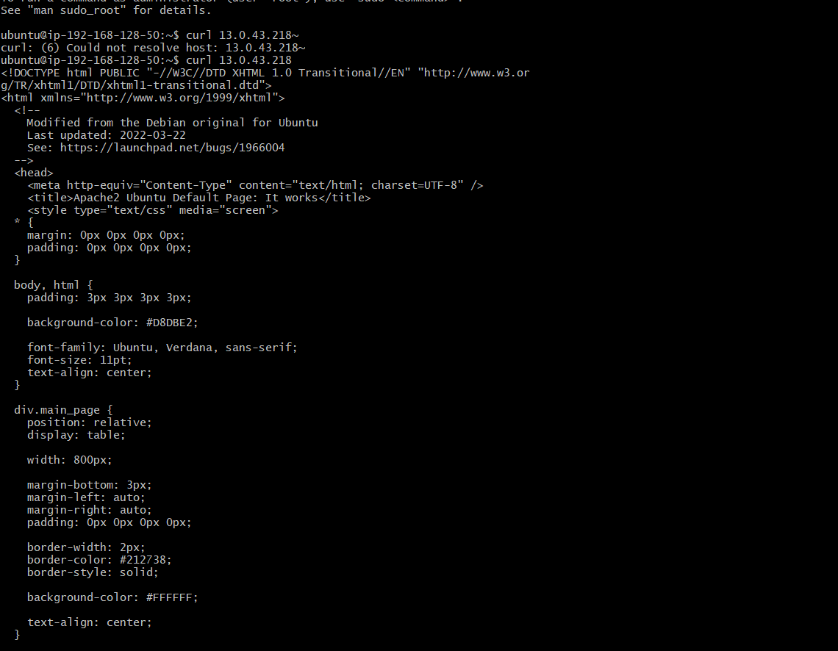

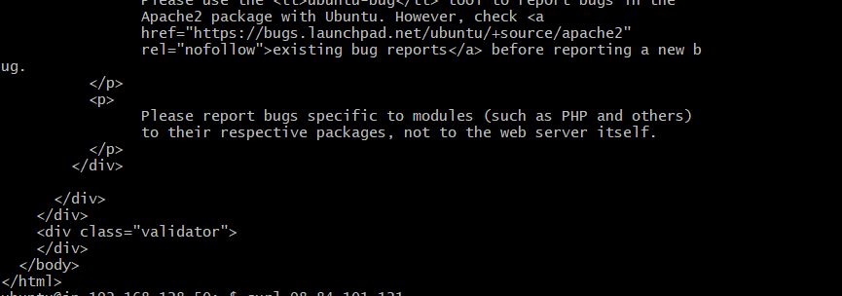

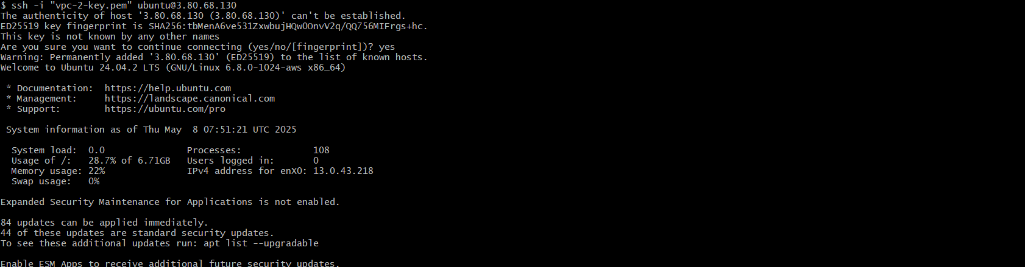

Similarly for vpc-2 also we should do the same process what we have done for the vpc-1 instance.

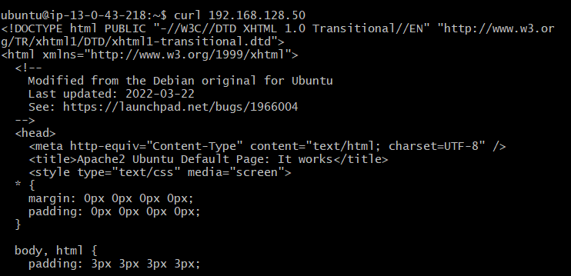

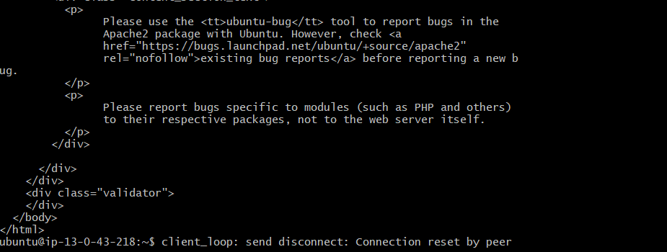

1. Enable VPC peering for cross account. (You can collaborate with your friend and do this task).

In the vpc-1 instance which we done cross peering

Similarly in this we will do the peering for cross accounts with their public ip address





1. Setup VPC Transist gateway.

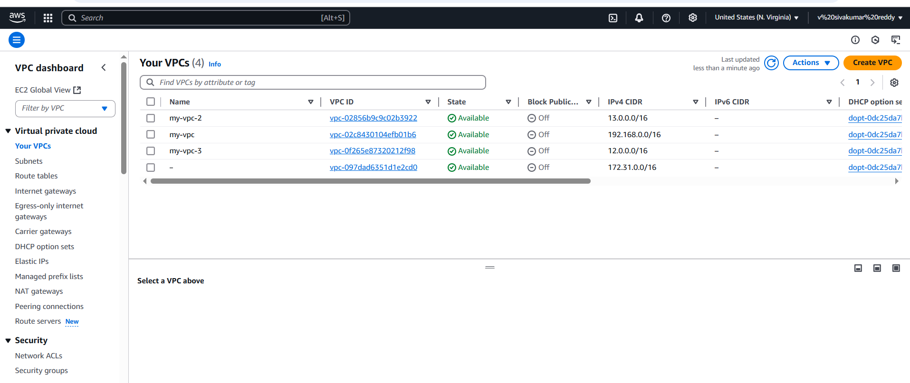

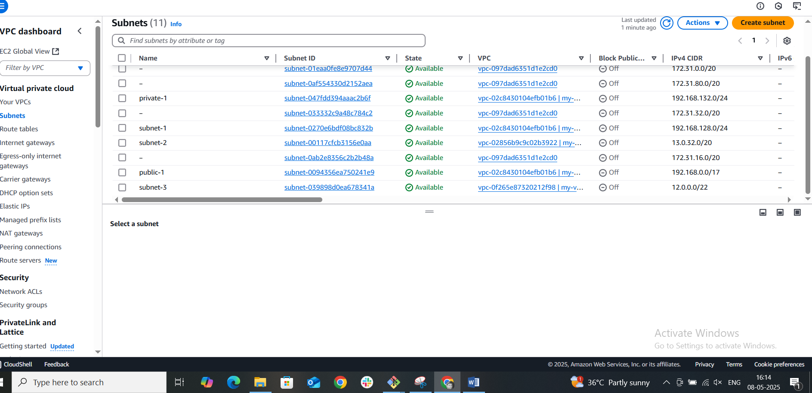

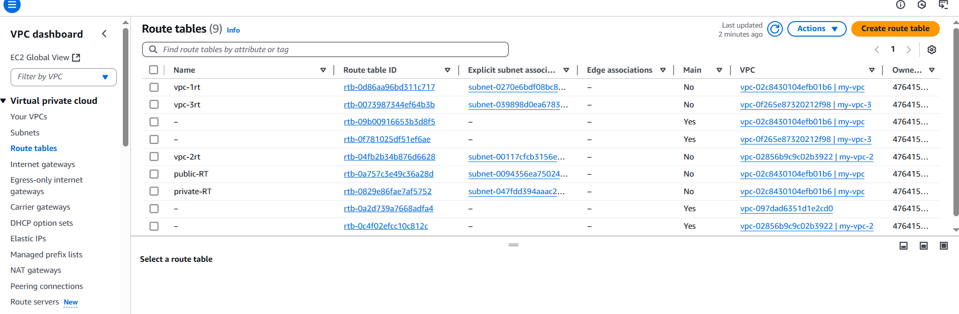

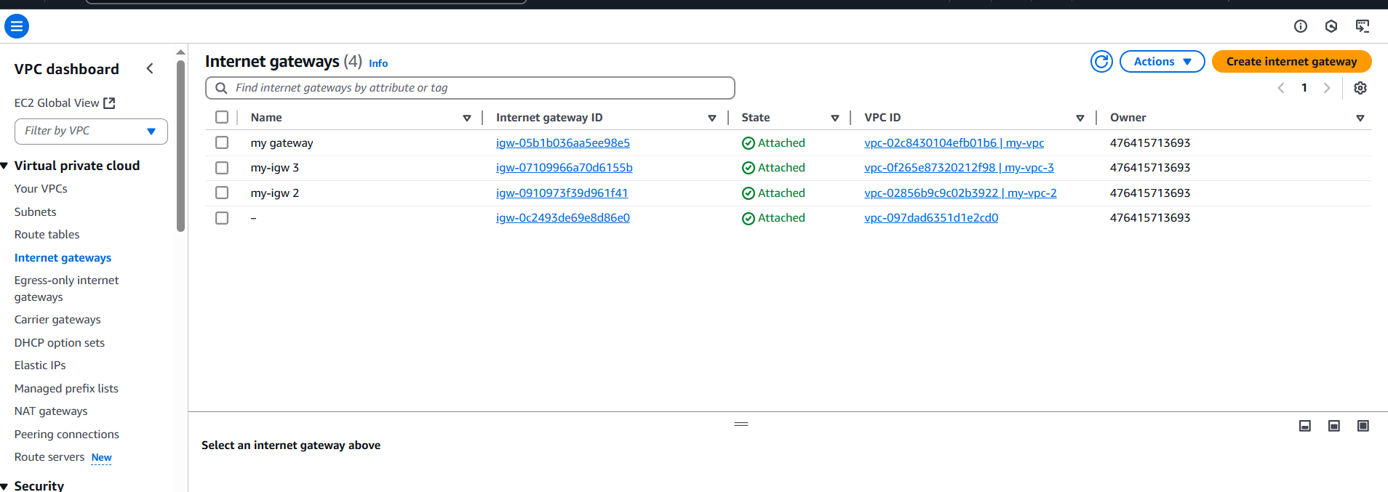

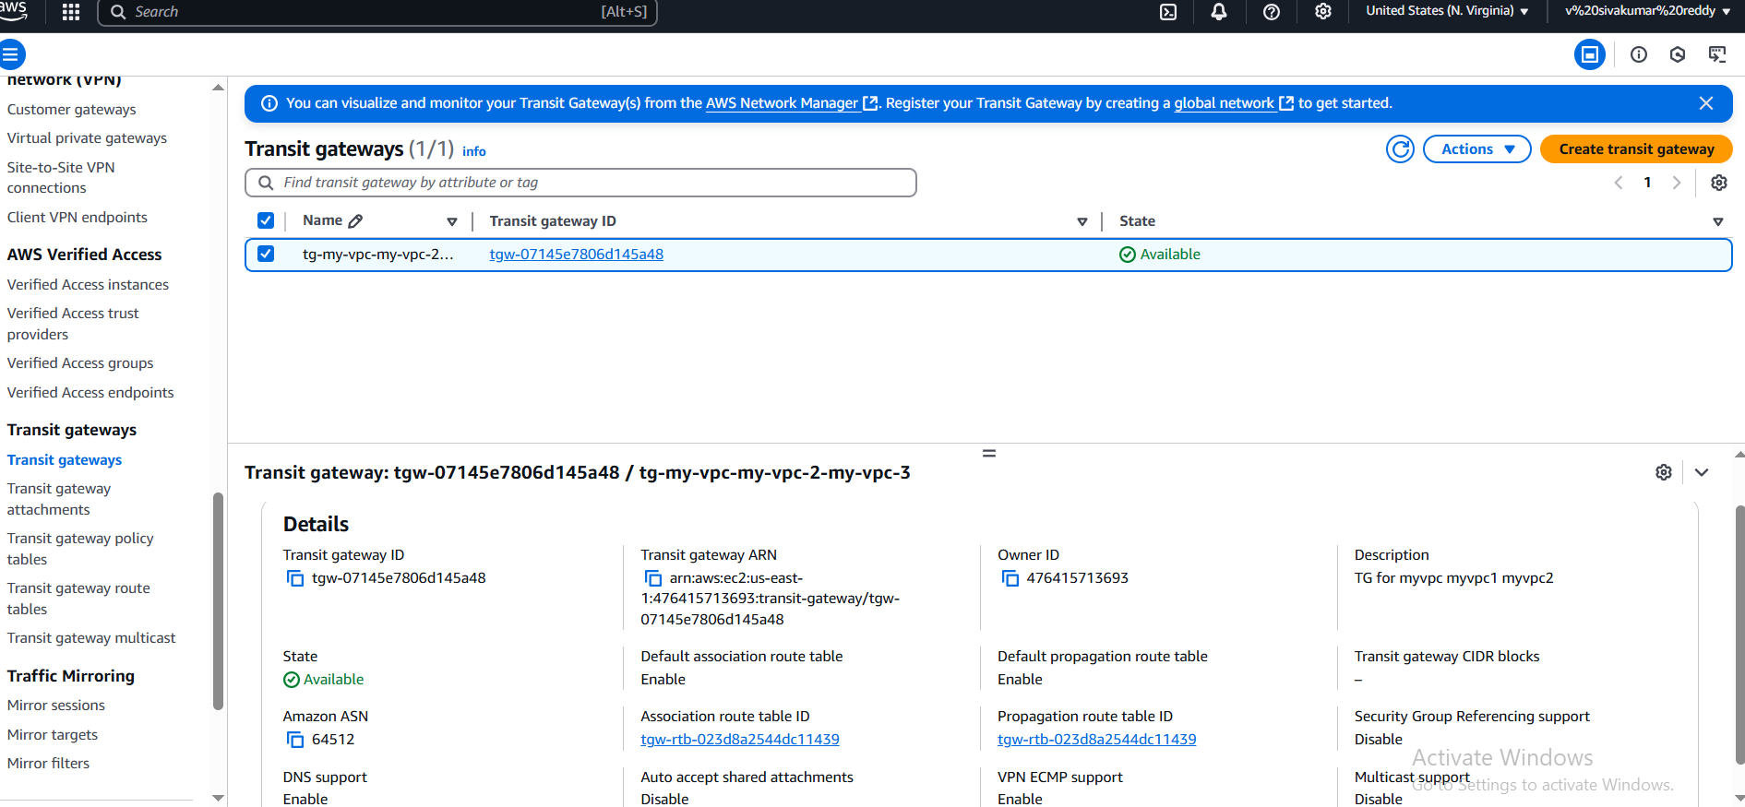

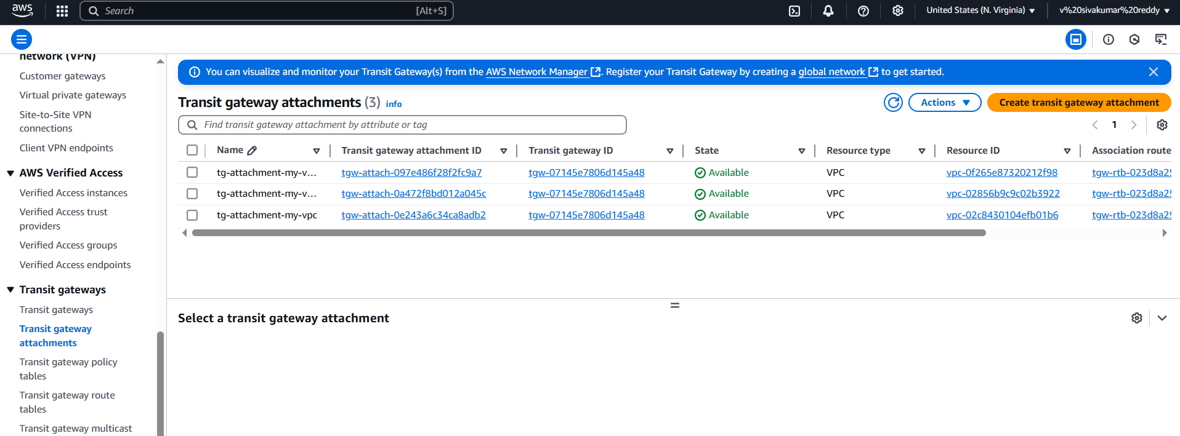

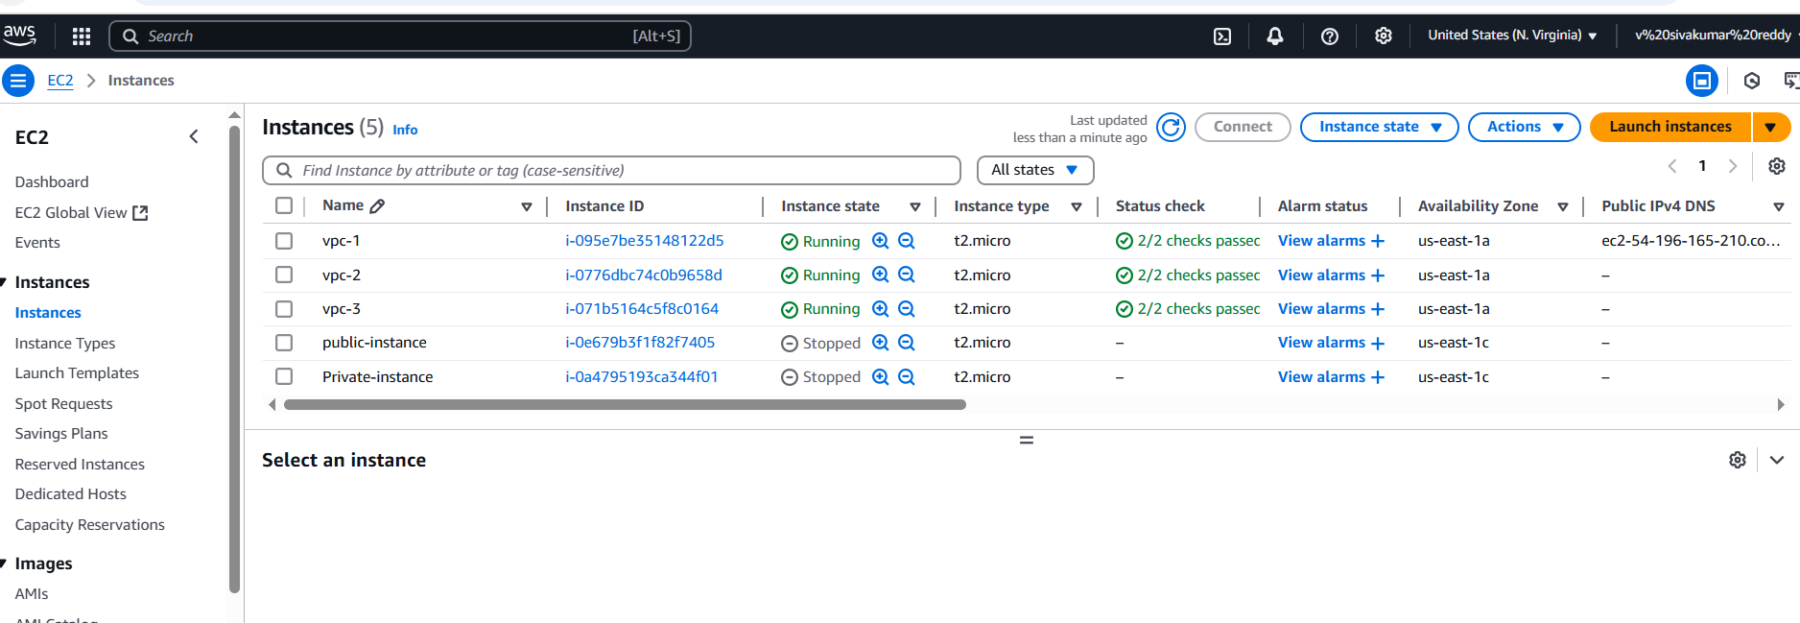





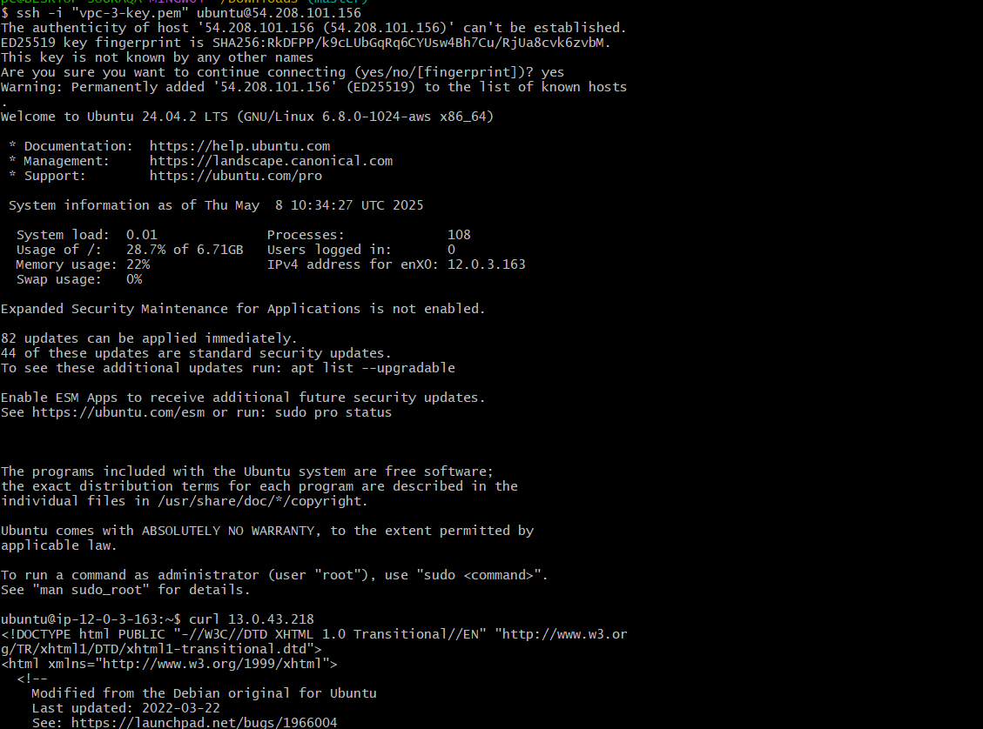

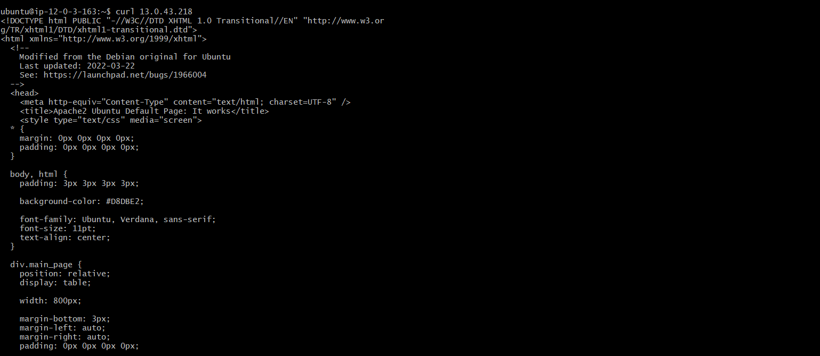

192.168.0.0/16

13.0.0.0/16

12.0.0.0/16

1. Setup VPC End Point.

